**Applied_SDLC-Dec_Team_17**

**MINI PROJECT**

**E BOOK FOR C PROGRAMMING**

**CONTENTS OF THE PROJECT:**

|  |  |
| --- | --- |
| **SR.NO** | **CONTENTS** |
| 1 | [Requirements](https://github.com/GENESIS2021Q1/Applied_SDLC-Sept_Team_27/tree/main/1_Requirements) |
| 2 | [Design](https://github.com/GENESIS2021Q1/Applied_SDLC-Sept_Team_27/tree/main/2_Design) |
| 3 | [Testplan](https://github.com/GENESIS2021Q1/Applied_SDLC-Sept_Team_27/tree/main/3_Testplan) |
| 4 | [Implementation](https://github.com/GENESIS2021Q1/Applied_SDLC-Sept_Team_27/tree/main/4_Implementation) |
| 5 | [Standup_Other](https://github.com/GENESIS2021Q1/Applied_SDLC-Sept_Team_27/tree/main/6_Standup_Other) |

**1_REQUIREMENTS:**

## INTRODUCTION

E-book is nothing but a digital file containing a body of text and images suitable for distributing electronically and displaying on-screen in a manner similar to a printed book. The COVID-19 has resulted in schools shut all across the world. Globally, over 1.2 billion children are out of the classroom. This project aims on providing education to the Technophile newbies. who are interested to learn C language. C language is a computer programming language that was developed to do system programming for the operating system UNIX and is an imperative programming language. This project first takes the user to a index page where the available contents on c program are listed and asks the user to give input for the respective topic he wants to review or study, after that it takes the user to that topic page where there are options to see further subtopics and example codes. User can also try run the example code by him/herself. User can also give suggestion to us.

# RESEARCH

**E-BOOK ON C PROGRAMMING...**

* This is a simple project which simply provide easy contents on c programming to the user after taking input from the user.
* This project is built using traditional file handling system rather than Data base system. here the user provides his/her desired choice and the code after taking input from the user it runs the respective user defined funtion which prints the contents of the respective topic.

## Cost and Features

* This project has various features, like it can provide contents on c programming concepts to the user.
* User also can run the given sample codes and try it by themself. which is a big plus point for this project.
* Users have option to give their valuable suggestions in or platform.

## Defining Our System

* System basically takes input from the user and checks for the file, and then it prints the file. for running the code it checks for the available code and run it in the compiler i.e GCC and prints the output
* for the suggestion part it takes suggestion from user and stores it in a file.

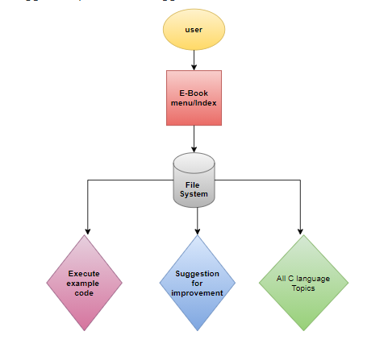

**SWOT ANALYSIS**

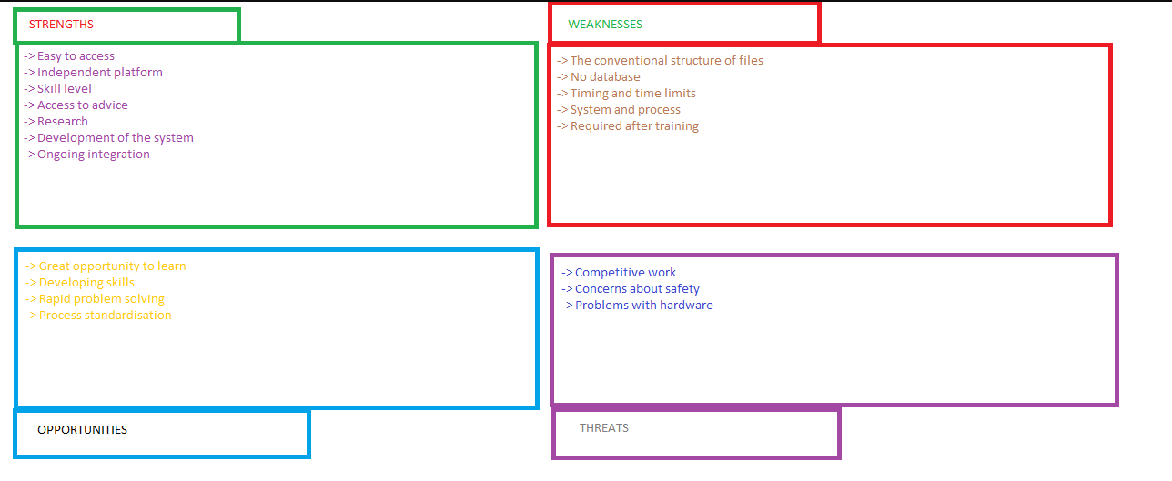

**DETAIL REQUIREMENTS**

## High Level Requirements:

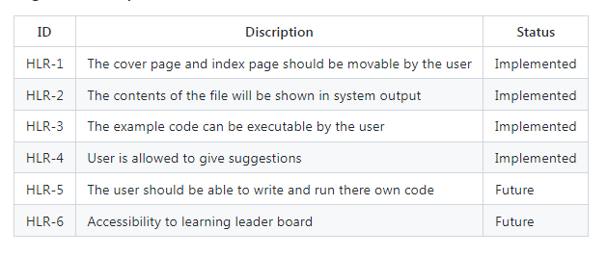

## Low level Requirements:

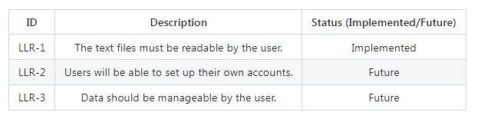

**2_Design:**

## High level Design

## Usecase Behavioural Diagram:

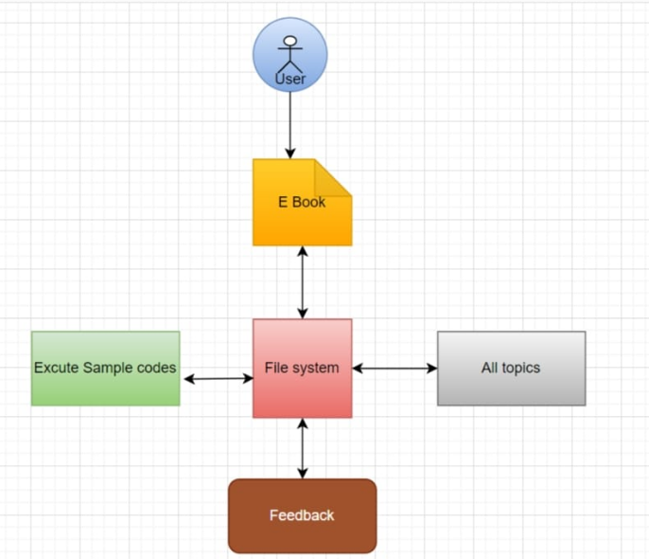

## Structural Diagram

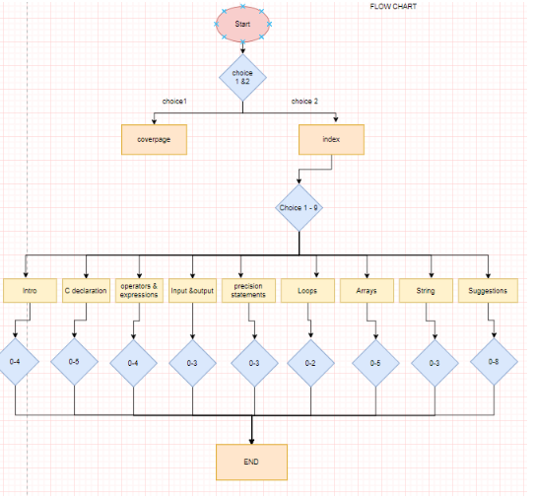

## Low level Diagram

## Behavioural diagram:

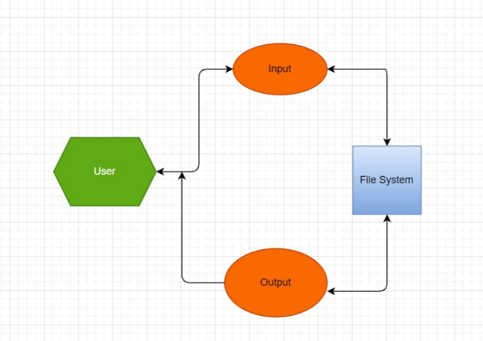

## Structural Diagram

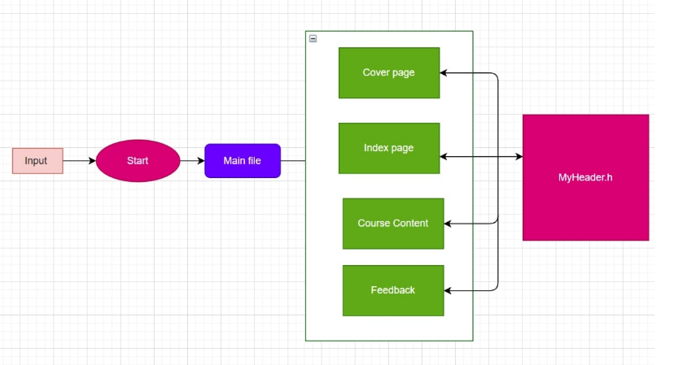

## TOOL

Draw.io

**3_TEST PLAN:**

## High level test plan:

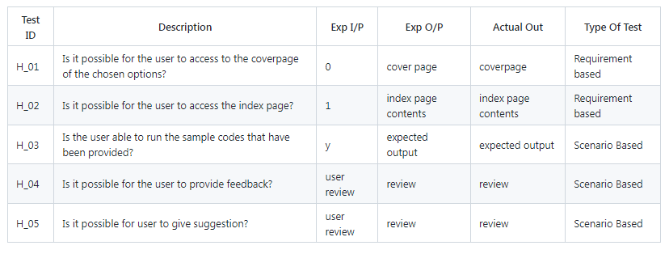

## Low level test plan:



# 4_IMPLEMENTATION:

**IDE Used in the Project:**

1. VISUAL STUDIO CODE

**INTRODUCTION:**

* An integrated development environment (IDE) is a feature-rich program that supports many aspects of software development. The Visual Studio IDE is a creative launching pad that you can use to edit, debug, and build code, and then publish an app. Over and above the standard editor and debugger that most IDEs provide, Visual Studio includes compilers, code completion tools, graphical designers, and many more features to enhance the software development process

## STEPS TO EXECUTE THE CODE:

* Run the main program
* The message displayed to is enter the choice

1. for the cover page

2. for index page

* If the choice is 1 cover page is displayed
* If the choice is 2 index page is displayed
  1. Introduction
  2. C Declerations
  3. Operators and expressions
  4. Input and output
  5. Decleration Statements
  6. Loops
  7. Array
  8. String
  9. Suggestions
* Enter any choice-if 1

1. The_First_C_Program

2. Header_Files

3. Languages_in_C

4. Advantages_of_C

* Choose any one .
* If we press 1 it shows the contents of The_First_C_Program.
* In order to got to the next press 1 option (Header_Files) and continue for same for the forther files.
* To go back to press 1 it redirects to the outline page again.
* Then press zero to go to the index.
* To run the example program press 1 then the program runs u can provide the input for what to be checked.
* After running the program press any key to exit.

**IMPLEMENTATION:**

**CODE EXECUTION AND OUTPUT:**

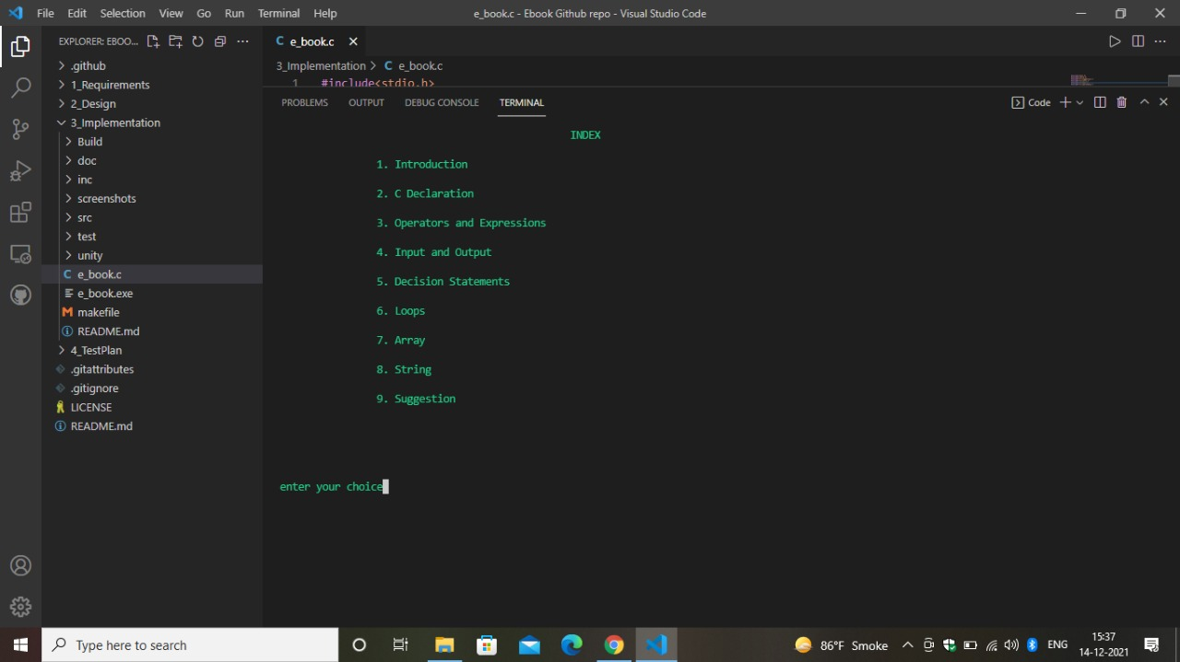

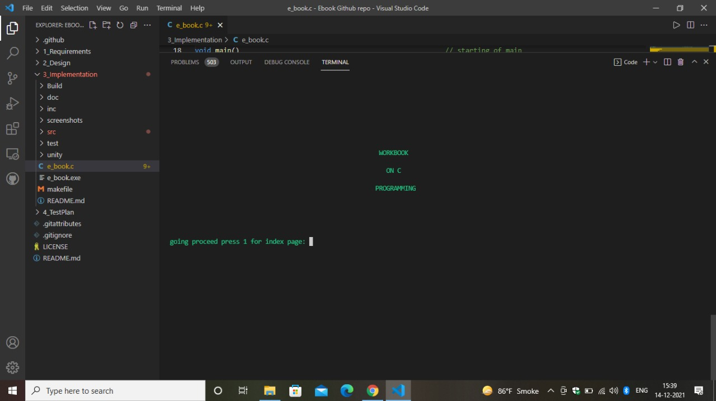

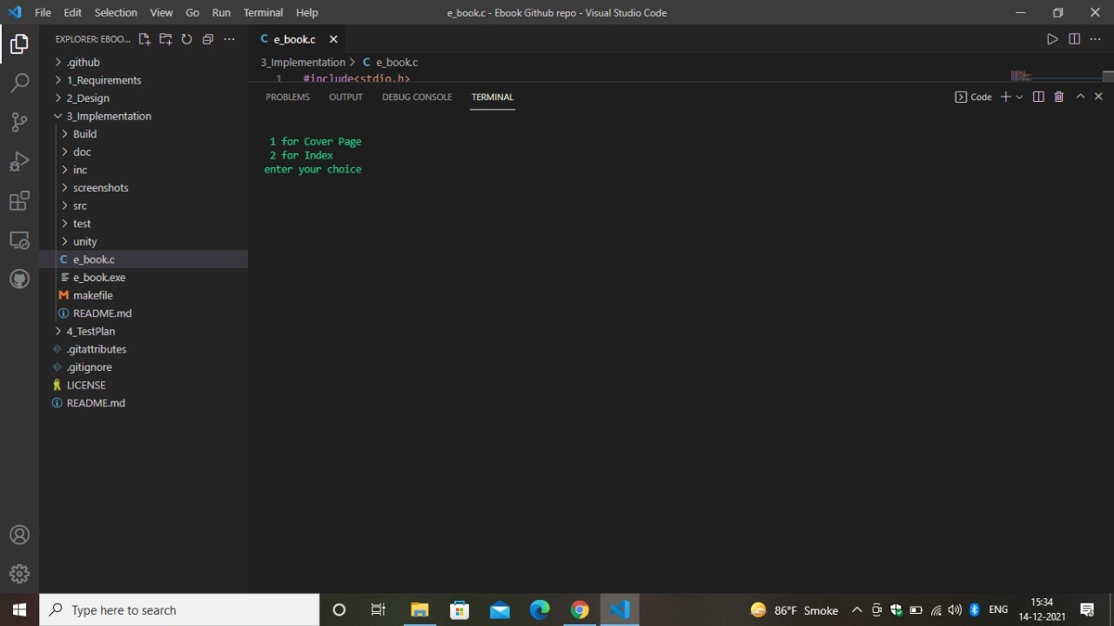

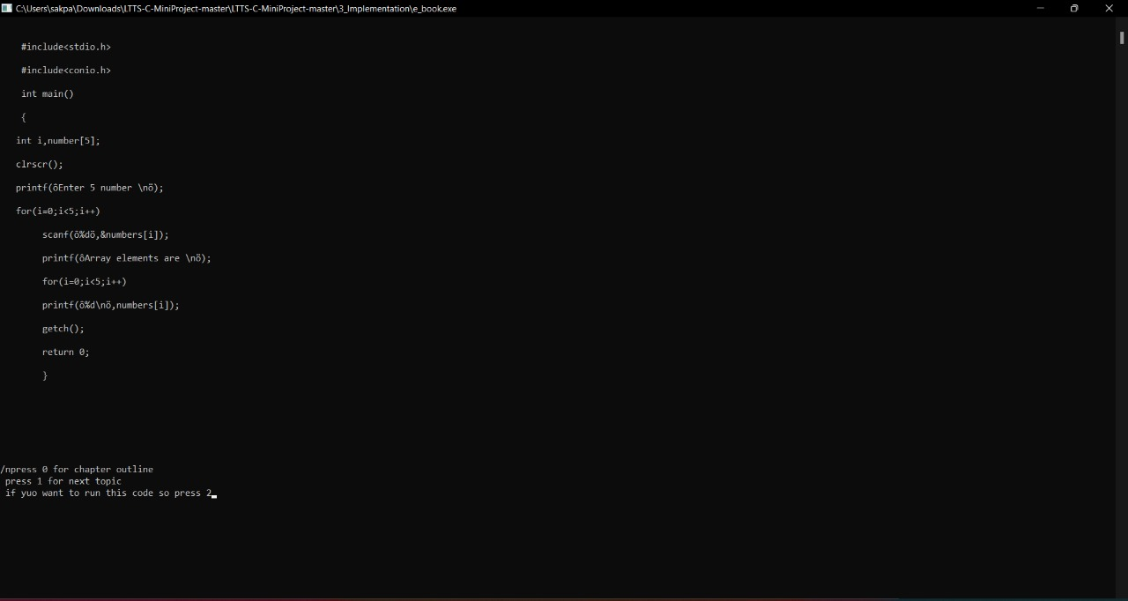

# ****5_Standup_Other:****

## Contributors List and Summary

|  |  |  |
| --- | --- | --- |
| **CONTRIBUTORS NAME** | **CONTRIBUTORS PSNO:** | **CONTRIBUTIONS** |
| Shaik Basha | 40020691 | Requirements part Folder Structure High level Design and In implementation part I did Suggestion . C code and CreatedAdvantags_of_c.text,Applications_of_Strings.txt, Arithmetic_Operators.txt,Array.txt,Array_Declaration.txt text files. |
| Omkar Verma | 40020692 | Requirements part Folder Structure low level test plan and In implementation part I did func.c code part, In and Out.c, test.c and Created text files. |
| Harikrishnan Mutheesvaran | 40020693 | Making SWOT DIAGRAM,SWOT ANALYSIS AND 4WS AND 1H.In addition to this i have made text files under src file and name as follows cover page, data type, decision statements, declaring variable and I have contributed for making main programming file that is ebook.c |
| Akshay Anant Butle | 40020694 | Folder Structure low level Design and In implementation part I did For_and_Nested.txt_, Goto_and_Switch.txt, Header_Files.txt ,Identifiers.txt files. |
| Manish Sakpal | 40020696 | Requirements part Low level requirements and in Implementation part I did operandexp.c and Created If_and_Else_Statements.txt, Index.txt, Input_and_Output.txt, Introduction.txt, Languages_in_C.txt text files. |
| Sonali Likhar | 40020697 | Requirements part High level requirements and In Implementation part I did loops.c and contributed for making main file, make file and header file  Introduction and research.In implementation part I am doing the array contents with texts files including with program examples. |
| Mamta Vishe | 40020699 | search part in requirements and In Implementation part decstat.c under source files also done the work on design part and demo code |
| Keerthana A | 40020702 | High level test plan and Low level test I did code part and created text files. |
| Kattamuri Bharath kumar | 40021915 | Cost and features in requirements part.In implementation part I am doing the pointers contents with texts files including with program examples. |

## Challenges Faced and How Was It Overcome:

1. Online resources were quite helpful during cpp-check.
2. Because most of the functions utilised incorporate other function calls and require user input, unit testing couldn't be done successfully in most of them.
3. when the numerous files are running Making a make file was quite helpful in resolving this issue.
4. Stack Overflow was quite helpful in resolving challenges during this assignment.

***Thank you***